Moonstone Class

Class Teacher: Miss Phillips

Teaching Assistants: Adele (mornings)

**Year 5/6 Learning Experience Term**

**Wootton St Peter’s CE Primary School**

***Perseverance Compassion Courage***

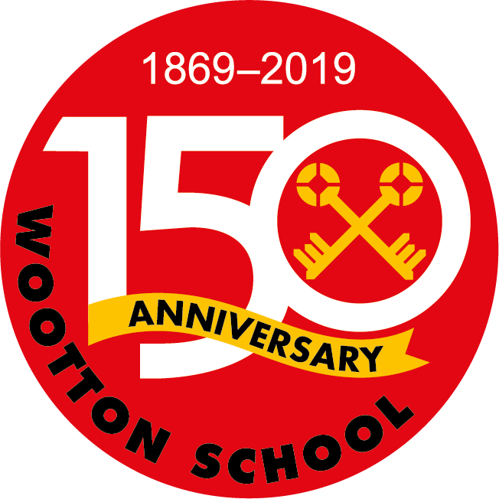

Welcome to Year 5/6

at Wootton School.

**Big Question: How did life in the Shang Dynasty compare to other Ancient Civilizations?**

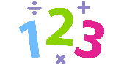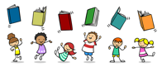

**Maths**

This term we will be looking at angles within shapes. We will cover position and directions. Then will move on to statistics and interpreting data. Finally we will look at measures and how to read bus timetables.

**Reading**

This term we will focus on whole class shared reading where children can deepen their understanding of the text and their level of comprehension. We will focus on extending their vocabulary using words form a range of texts. Also we will work on comprehension skills, look at authors choice of language and interpreting texts.

**Writing**

Our writing this term will be linked to the book ‘The Firework Makers Daughter’ by Phillip Pullman. We will design our own fireworks and write instructions for how to make them. We will also be writing stories and letters.

**PE - Important Information.**

PE is on a **Wednesday and Friday.** All children must have a PE kit, which is a white T-shirt or the colour of their house team (red, yellow, blue or red), black shorts or joggers and trainers.

**Books / Play**

Children are encouraged to take chapter books home from our class library.

This term we will be performing our play ‘Pirates of the Curry Bean’. For reading this term, please help your child to practice and learn their lines off by heart. This will really help us to be able to focus on the acting at school.

**Homework.**

Homework will be sent out on a Friday and is due in on Thursday. The children will be set weekly spellings and some work based upon what we have done in class that week. Please take time to work with your child, to help them with anything they’re finding difficult.

**History**

This term we will be learning about the Shang Dynasty. We will look at Shang rulers and their customs and beliefs. We will look at how artefacts tell us about the past, by learning about the terracotta warriors and dragon/ oracle bones. We will compare the Shang Dynasty to other Ancient civilizations, which we have learnt about this year.

**PSHE**

This term we will be thinking about ‘being our best’. The children will explore different skills, learn about their school community and independence and responsibility. We will also look at the book ‘Mammie Takes and Stand’, and how this has helped to influence education today.

**Design Technology**

This term the children will be designing and making their own moving toy, using cams and cogs. They will saw the dowels, for the cams to go onto. **Please bring in a shoe box, if you have one.**

**RE**

We will continue to learn about the religion of Islam and the importance of Ramadan and Eid. We will be thinking about the big question ‘ Does belief in Akhirah (life after death) help Muslims lead good lives?

**Science**

This term we will be learning about electricity. The children will explore hoe the number of cells in a circuit affect the volume of a buzzer or the brightness of a lamp. They will learn how to use circuit symbols to create diagrams.