Year 1/2 Opal Year A 2020/2021
Autumn 1  Why are homes important? |  | Autumn 2  How can we look after each other? |  | Spring 1 | Spring 2 | Summer 1 | Summer 2
2.3 wks  2/9 – 18/9 | 5 wks  21/9 – 23/10 | 4 wks  2/11 -27/11 | 3 wks  30/11 – 18/12 | 6 wks  4/1 – 12/2 | 5.3 wks  22/2 -31/3 | 6 wks  19/4 – 28/5 | 6.4 wks  7/6 – 22/7
Whole School Project | Homes  Harvest Final week of term. | Owls | The Nativity | The Great Fire of London | Forests | Circus | The Seaside
Here we are. Oliver Jeffers  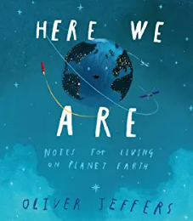 | The Three Little Pigs.  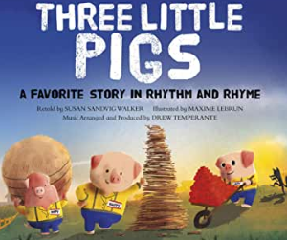 | Owl Babies  Martin Waddell  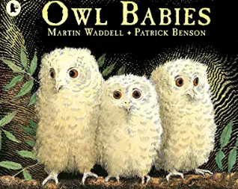 | The Nativity Story / The Star that went Zoom  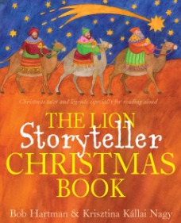 | The Great Fire of London  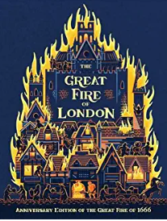 | Where the Wild things are.  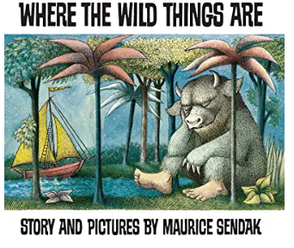 | I want my hat back  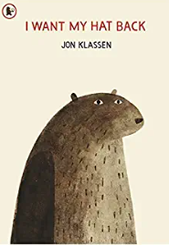  The monkeys and the hats  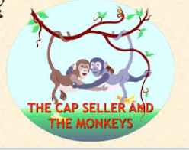 | The Storm Whale  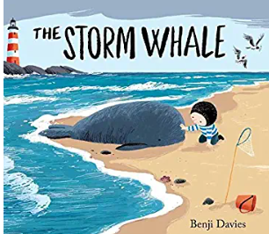 | The Secret of Black Rock  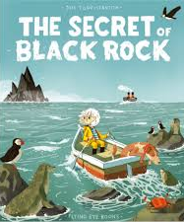
Year 1/2 Opal Year B 2021/2022
Autumn 1 |  | Autumn 2 |  | Spring 1 | Spring 2 | Summer 1 | Summer 2
7.3 wks |  | 4 wks | 3 wks | 6 wks | 5.3 wks | 6 wks | 6.4 wks
Whole School Project  Out local area. |  | Take one Book/  Africa | The Nativity | Polar Regions/Explorers | Knight and Castles (George and the Dragon) | Space | Rainforests
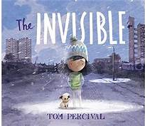  The Invisible Tom Percival  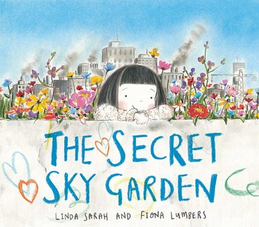  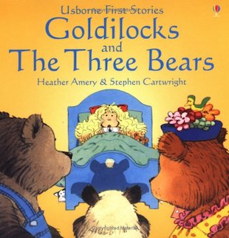  The Secret Sky Garden  Linda Sarah |  | Meerkat Mail  Emily Gravett  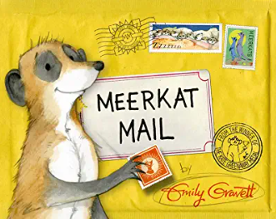 | The Nativity Story / The Christmas Story  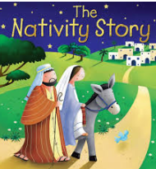 | The Great Explorer  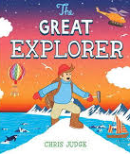 | Egg Box Dragon  Richard Adams  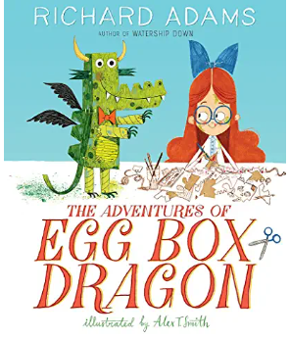 | Hermelin  Mini Grey  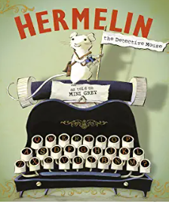 | The Freedom Bird  Chris Smith  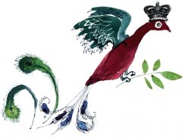

Year 1/2 Opal Year B 2021/2022
Autumn 1 | Autumn 2 |  | Spring 1 | Spring 2 | Summer 1 | Summer 2
7.1 wks  Fri 3rd Sept –  Thurs 21st Oct | 7 wks  Mon 1st Nov –  Fri 17th Dec |  | 6.3 wks  Wed 5th Jan –  Fri 18th Feb | 6 wks  Mon 28th Feb –  Fri 8th April | 5 wks  Mon 25th Apr –  Fri 27th May | 6.4 wks  Tues 7th June –  Thurs 21st July
Us, Homes, Community | Take one Book/  Africa | The Nativity | Polar Regions/Explorers | Knight and Castles (George and the Dragon) | Our Local Area | Rainforests
The Invisible Tom Percival  The Secret Sky Garden  Linda Sarah | Meerkat Mail  Emily Gravett | The Nativity Story / The Christmas Story | The Great Explorer | Egg Box Dragon  Richard Adams | Hermelin  Mini Grey | The Freedom Bird  Chris Smith
English  Book 1 The Invisible  (Two weeks)  Belonging/Word definitions. (Whole Class)  Things we take for granted what makes you safe and happy? *shared & Indep)  Feeling Sad – emotions (Whole Class)  Importance of Community (Whole class)  Walking in others shoes,  (Whole Class)  Describe your favourite.  piece of clothing? (Indep)  Describe what you have in your bedroom. (Indep)  Describe your house. (Indep)  How is Isobel feeling?  What does Isobel look like? (Whole Class)  Describe the people in your family you like/love. (Indep)  Happy Memories poster, (indep)  Find something that is beautiful – write a description (Indep) | I can write a postcard about a happy day at school.  I can map the story  Familiarisation with text what happens when?  I can describe where Sunny lives.  I can write a postcard from Sunny about his visit to Oxford  I can write a postcard from Sunny about his visit to Wootton school.  I can recount Sunny’s trip.  I can write about what it’s like for sunny when he arrives home. | I can sequence the Christmas story.  Tell and map/sequence the Christmas story  I can use noun phrases to describe.  Wise men’s journey  I can use adverbs for description.  The stable  I can start my sentences in different ways.  Mary and Joseph arriving in Bethlehem, | Postcard home about day 1 of our expedition.  Write a list of what’s needed in an expedition backpack  I can sequence events in a story.  Map story and create word bank of words needed to tell the story.  I write about real events  I can use adjectives and adverbs for description.  Diary entry day one of the trek to the pole.  Diary entry day two of the trek to the pole.  Diary entry day three of the trek to the pole. | Chn visualise and paint the dragon after hearing the story.  Chn sketch their own dragon and annotate it,  Create a list of resources needed to create it.  Create a set of instructions to make their own egg box dragons. Laminate & display.  Ask children to predict what they think might happen if the egg box dragon is put to sleep under the moon. Draw what they see and annotate with a friend.  Chn write this part of the story, answering the questions of what happens under the moon that night.  Chn edit their work ‘under the moon’ adventures, give children silver pens and navy blue paper to write up their stories. | Write a letter to Hermelin  Understand new vocabulary.  Write a list of people who live in Ottley St.  Map the story.  Write a letter to apply for the job.  Correct a letter.  Look at conjunctions.  Write another letter describing themselves.  Write a story with an animal as a detective.  Create an advert for Bosher’s sausage shop.  Newspaper article about the disappearance of things on Ottley street.  Create a notice for the Ottley Noticeboard | I can map the key parts of a story.  I can use similes and alliteration.  In pairs, act out/freeze frame 1 of 15 key moments of the story. Then write short, descriptive poems for each moment. Create a class poem.  I use powerful vocabulary to describe.  I can use poetic language features (similes/alliteration.)  Write a senses poem, in role as the hunter.  I heard…  I saw…  I touched…  I wondered…
Book 2 The Secret Sky Garden (Two weeks)  Photos of litter in schools nad parks – write labels.  Litter and Wildlife  Make notes/fact cards about how rubbish affects Wildlife.  Keep Wootton Tidy Poster  Letter asking for a new play ground bin in the shape of a ?  Poem about nature and or outside area.  Funni role oon the wall.  Funni Character description. (Name, her appearance, background, likes and dislikes.  Instructions for being a good friend.  Letters to parents for seeds, plants, compost.  Create garden area. | I I can map and tell an explanation text.  know the features of an explanation text.  I can write an explanation text about Meerkats. | I can use adjectives to make my writing interesting.  Read The Cat in the Manger.  I can write in role  Write from the donkey’s point of view, about the journey to Bethlehem.  I can use powerful verbs  I can follow the pattern of a poem.  Write ‘Christmas is when’ poem. | I can write about real events.  Describe the Northern lights,  Describe how to make a campfire.  I use adjectives and adverbs for description.  Fact files on Polar Bears. | Egg box dragon role on the wall. Whole class then chn to work in small groups to produce their own role on the wall posters for the little dragon.  Create a kenning (eater, liver, feller, dweller)  “Egg Box Dragon was perfectly friendly…” to “terrifying the next-door cat”. Freeze Frame & CHn annotate.  Chn write to Egg Box Dragon as their chosen character explaining who they are, what they have lost and asking for his help. How will they persuade him to help them?  Explain to the class that they are going to work in small groups to create their own television interviews with Egg Box Dragon.  Chn Respond to Illustration |  | Think about how a character may be feeling.  Focus on 3 different stages of the story, what is the hunter thinking? What is the hunter feeling?  Explain what a character is like. I can describe a character.  Discuss what we know about the hunter from the story. What can we guess about him? Likes, dislikes, strengths, weaknesses.  Fill in a job application form.  Write in role as a character.  Write the hunter’s diary entry, the day he tries to kill the freedom bird. Does he feel guilty? Why did he shoot the bird?  Write in role as a character.  Write a letter to a friend, the day he finds the 100 freedom birds. How does he feel now? What has he learned?
Book 3 Goldilocks  (Two weeks)  Sequence the story.  Describe Goldilocks.  Describe one of the three bears.  Create a missing poster for Goldilocks.  Write instructions for making porridge.  Write a sorry letter from Goldilocks |  | I can use powerful adjectives.  I can follow the pattern of a poem.  Write Christmas recipe poem  A pinch of frosty snow,  A cup full of fun  Take poems home to give as a gift. |  | Children work independently to write their own invitation for the Queen’s party.  Children write their own short letters in role as the Queen.  What might a magpie who likes shiny, glittery items be attracted to?  Ask children to work in groups to create a list of as many items as possible  Hand out a sentence strip to each child and ask them to choose one item from the list that they can clearly visualise.  Create a class poem.  Fact file about a Magpie.  Now that Egg Box Dragon has helped the Queen, what might happen to him next? Discuss potential new adventures for Egg Box Dragon.  Chn create own stories. |  | Describe a setting  Describe rainforest setting and bird, adding detail to the opening of the story. (establish the place.)  Use powerful vocabulary to describe.  Describe the hunter’s house, adding detail to the build-up section of the story.  Describe what it is like by the river using powerful adjectives.  Write dialogue  Write build-up section of the story, including dialogue. (Add a second hunter – a friend.)  Use powerful vocabulary to describe.  (Link to art of Freedom Bird)  Hunter decides to protect the freedom bird from others. Write posters/leaflets explaining how to recognise a freedom bird and what to do if you see one.
Use powerful vocabulary to describe.
Plan new animal, what would it do that would irritate the hunter. Write description of animal, what does it remind the hunter of.
LO I can write a complete story with a beginning, middle and end.
Children to change the animal, and what the hunter does to get rid of it.
Non-chron report intro to rainforest.
Non-chron report about layers of rainforest.
Non- chron report about a rainforest animal.
Non-chron report about insects.

Maths  (White Rose/Hamilton/Twinkl)  Number & Place Value (4)  Number, Addition & Subtraction (3) | Addition & Subtraction (2)  Shape (2)  Money (2)  Christmas Maths (1) |  | Multiplication & division (3)  Place Value (2)  Time (1.5) | Measurement length & height (2)  Fractions (2)  Measurement weight and Volume (2) | Properties of shape (2)  Time (1)  Place Value (2) | Position & Direction (2)  Fractions (2)  Place Value (2)  Money (1)
Science  Seasons Name them  How are they different?  Make a seasons wheel.  Plant seeds and bulbs to create an Opal garden.  Grow a cress head.  Collect seeds from outside area. | I know facts about Meerkat  Create Fact File  Chn write facts around the outline of a meerkat.  Identify that most living things live in habitats to which they are suited and describe how different habitats provide for the basic needs of different kinds of animals and plants, and how they depend on each other  Describe how animals obtain their food from plants and other animals, using the idea of a simple food chain, and identify and name different sources of food.  5 senses  Visit to a Farm |  | Identify that humans and some animals have skeletons for support, protection and movement.  Identify how animals and plants are suited to and adapt to their environment in different ways – hibernation.  Materials – which materials keep things warm for the longest time?  And cold for the longest time?  How can you melt ice?  What would a polar explorer wear to keep warm? | I  Identify and compare the suitability of a variety of everyday materials, including wood, metal, plastic, glass, brick, rock, paper and cardboard for particular uses  Find out how the shapes of solid objects made from some materials can be changed by squashing, bending, twisting and stretching.  Visit to Science Oxford | Identify and name a variety of common animals that are carnivores, herbivores and omnivore.  Identify, name, draw and label the basic parts of a mouse and the human body and say which part of the body is associated with each sense  Find out about and describe the basic needs of animals, including humans, for survival (water, food and air) 3.  Describe the importance for humans of exercise, eating the right amounts of different types of food, and hygiene | Explore the features of the rainforest and learn about the animals that live there.  Research facts about an animal that lives in the Rainforest  Present my animal study to the class  Children create own mini information books showing the animals that live in each layer.  Habitats - create a playdoh animal to match the habitat.  Visit to the Living Rainforest.
Geography  Look at our local community who lives in Wootton?  Walk around the village  (Tuesday p.m. John can helo)  Who works in Wootton who helps us?  Find out about these professions. | I can use an atlas to identify the Kalahari desert and nearby countries.  Chn use atlases to find Kalahari and notice which countries are located there. Then mark on a blank map and draw a key for desert and ocean.  Mapping Sunny’s journey. Through Namibia/Botswana, Ethiopia, Tanzania, Sri-Lanka, Liberia, Madagascar, South African Marshes.  I can compare homes in the UK with homes in Africa. Show ppt. Discuss what is the same in UK and Africa and what is different. Chn then complete a Venn diagram.  Similarities and differences between Africa and UK. |  | I ask and answer geographical questions.  I use world maps, atlases and globes  Looking at where Antarctica is, what it is like?  On a world map colour and label the UK and Antarctica then mark the best route from the UK to Antarctica. | Where are there castles in the UK?  Features of a castle | Find where we live on a map, look at here we live using google earth.  Keep a weather diary.  Draw a map of our school/village with a key. | What is a Rainforest?  Where in the world are rainforests?  Know geographical language relating to the rainforest.  Locate rainforests on a map. Find the Equator. Use maps, atlases and globes to identify the UK Name and locate the world’s continents and oceans. To know the location of hot and cold areas of the world in relation to the Equator.)  Know the different layers of the rainforest.  Develop geographical vocabulary relating to rainforests and understand features of the rainforest.  Investigate the destruction of the rainforest and its effect on animal species of the rainforest and investigate how places can change over time.
History  Florence Nightingale  Thinking Map what have we found out about her?  Famous nurse link to people who help us.  Fact sheet about FN  Timeline how she improved hospitals. | Not taught in this topic. |  | Place events, artefacts and historical figures on a time line using dates.  Understand the concept of change over time,  Use dates and terms to describe events. –expedition to the pole.  Learn about the Titanic. (Key event beyond living memory) | Chn develop their understanding of changes in national life that have occurred within living memory, particularly in terms of technology, fashion, entertainment and toys.  St George and the dragon.  Chn learn about castles and label the key parts of a castle. | What do we mean by Old fashioned?  Typewriter.  Think about old fashioned objects and toys.  Blackboard and chalk.  Ink pens  Skipping/marbles.  Snakes and ladders  Ludo.  Bring in Old fashioned toys and objects.  Old TV programmes.  Record Players/CD Players. | Not taught in this topic.
Art  Paint a picture of your house.  Sketch trees and leaves outside.  Draw a robin.  Make paper flowers, | Chn learn to draw a Meerkat and create Meerkat pictures  Introduction to African art. Chn create African Tiles to hang from the ceiling.  Printing African Patterns. |  | Paint the Northern Lights. | Children try drawing a range of different characters inspired by different animals, toys or models.  Drawing different faces using a range of media. |  | Paint the Freedom bird.
D&T  Gratitude Jar/Box  (To contain things we are thankful for)  Tissue paper flowers  Three Bear Puppets.  Make a paper maiched bowl. | Introduction to Africa ppt. Children to make African jewellery |  | Create a Marshmallow igloo. | Children can be provided with opportunities to design, make and evaluate their own dragon models inspired by Egg Box Dragon.  Prepare a menu, and potentially food, for the Queen’s tea party.  Chn create a knight cutting and connecting using split pins.  Chn design a sword & shield. And make it. |  | Make Bird Masks.  LO: To master techniques – collage Use a combination of materials that are cut, torn and glued. Arrange materials. Mix materials to create texture.  Create 4 layers of the rainforest in groups (shoeboxes.)  3/4 Layers of the rainforests, animals  LO: I can make a rainforest animal from masking tape

RE  UC  Gospel  Tell stories from the Bible.  Give clear, simple accounts of what Bible texts (such as the story of Matthew the tax collector) mean to Christians.  Recognise that Jesus gives instructions to people about how to behave.  Give examples of ways in which Christians follow the teachings studied about forgiveness and peace and bringing good news to the friendless.  Give examples of how Christians put these beliefs into practice in the Church community and their own lives (for example: charity, confession). | Dis Rel  Has Christmas lost it’s true meaning?  Reflect on Christmas story.  What gifts did Jesus receive?  What gifts would be meaningful to Jesus?  What’s special to you?  Why do Christians believe Jesus is a special gift from God? | Dis Rel  Christianity.  Does God want Christians to look after the world?  Jesus as a friend.  Jesus looking after his friends in a storm.  Jesus and Zacchaeus.  Jesus – Mary, Martha & Lazarus. | Dis Rel  Easter Story  Palm Sunday  Why is Jesus Special to Christians?  UC  Salvation  Recognise that Incarnation and Salvation are part of a ‘big story’ of the Bible.  Tell stories of Holy Week and Easter from the Bible and recognise a link with the idea of Salvation Recognise that Jesus gives instructions about how to behave.  Give examples of how Christians show their beliefs about Jesus’ death and resurrection in church worship at Easter.  Think, talk and ask questions about whether the story of Easter has anything to say to them about sadness, hope or heaven, exploring different ideas. | Dis Rel  Judaism  I can explain why Shabbat is important to Jewish Children?  I can use the right names for things that are important to Jewish People during Shabbat.  I can talk about what Jewish people do to celebrate Shabbat.  Chanukah | UC  God  Identify what a parable is.  Tell the story of the Lost Son from the Bible simply, and recognise a link with the concept of God as a forgiving Father.  Give clear, simple accounts of what the story means to Christians. Give at least two examples of a way in which Christians show their belief in God as loving and forgiving; for example, by saying sorry;  Give an example of how Christians put their beliefs into practice in worship; by saying sorry to God,
PSHE (Scarf Year 2)  Our ideal Classroom 1  Our Ideal Classroom 2  How are you feeling today?  Bullying or Teasing  Don’t do that  Types of Bullying  Being a Good Friend  Let’s all be happy, | What makes us who we are?  How do we make others feel?  My special people.  When someone is feeling left out.  An act of Kindness.  Solve the problem. | Harold’s picnic  How safe would you feel?  What should Harold say?  I don’t like that.  Fun or not?  Should I tell?  Some secrets should never be kept. | Getting on with others  When I feel like erupting  Feeling safe.  How can we look after our environment?  Harold safes for something special.  Harold goes camping.  Playing Games. | You can do it.  My day  Harold’s postcard – helping us to keep clean and healthy.  Harold’s bathroom.  My body needs.  What does my body do? | A helping hand.  Sam moves away.  Haven’t you grown  My body, your body.  Respecting privacy.  Basic First Aid.
ICT  Learn to login to Google classroom and create a poster (wanted poster for Goldilocks) | Use paint on the Chrome Books. | Online safety  Writing emails  Word Processing | Programming  Bee Bots  Scratch. | Typing Text | Search Engines
Phonics
RWI
Music  Learn the Goldilocks song  Harvest songs  Big Red Combine Harvester.  In the Autumn leaves star a falling. | Nativity Songs. | Charanga  Friendship Song | Charanga  Our World | Charanga  Rhythm in the way we walk. | Charanga  Zootime  African Music
New Scheme to be introduced.  Catching & Throwing | Multi Skills/Yoga | Gymnastics |  | Cricket/Tennis | Athletics

